OSPF (Open Shortest Path First) is a link-state interior gateway protocol — an open standard (OSPFv2 for IPv4, RFC 2328; OSPFv3 for IPv6). Unlike distance-vector protocols that share their whole routing table with neighbors ("routing by rumor"), each OSPF router builds a full map of the topology and computes its own paths.
The mechanics, briefly:
- Neighbors and LSAs. Routers discover each other with Hello packets and then exchange Link-State Advertisements describing their links and costs. Every router in an area floods and stores these in a shared link-state database (LSDB) — so all routers in an area see an identical map.
- SPF / Dijkstra. Each router runs the Dijkstra shortest-path-first algorithm against that LSDB to compute the lowest-cost path to every destination. Cost is the metric, derived from bandwidth by default (lower cost = preferred), which is why OSPF makes smart bandwidth-aware decisions where a hop-count protocol like RIP wouldn't.
- Areas. OSPF scales through hierarchy. Area 0 is the backbone; all other areas must connect to it, typically through an ABR (Area Border Router). Areas limit the scope of LSA flooding and SPF recalculation, which keeps large networks stable.
- DR/BDR. On multi-access segments (like your Switch4 segment), OSPF elects a Designated Router and Backup DR so routers don't have to form full adjacencies with each other in an n² mesh — they all adjacent to the DR instead. This is the specific behavior your topology showcases.
That's the topology
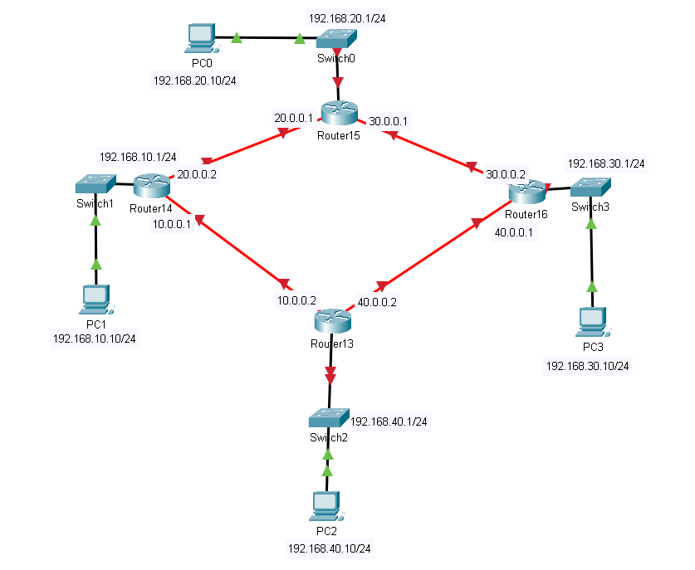
We going to add a non-empty router so we can add the interfaces cause we going to exceed the normal size of interfaces
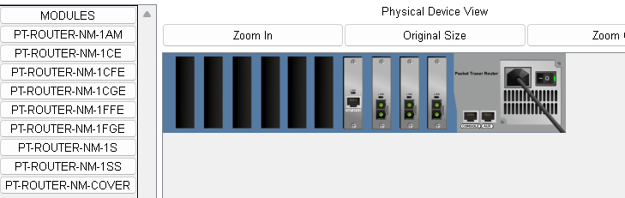
I have added Cisco Gigabit Ethernet Network Module (part number PT-ROUTER-NM-1FGE) provides Gigabit Ethernet copper connectivity for access routers.

And The PT-ROUTER-NM-1CFE Module provides one Fast-Ethernet interface for use with copper media.
After applying the topology start on configuring the IP of each device from ip configuration
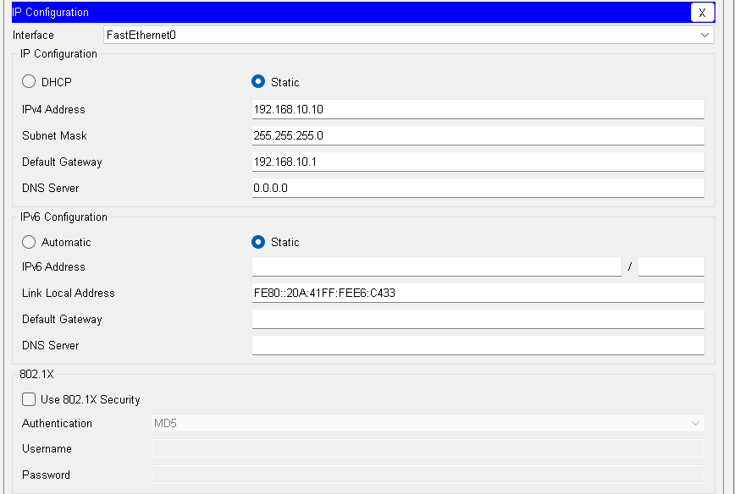
And for routers
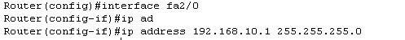
After finishing all PCs start on configuring the routers and make sure you make the CIDR /30 to stop the waste of Subnet
10/20/30/40.0.0.0 aren't all private. Only 10.0.0.0/8 is RFC 1918 — 20, 30 and 40 are publicly routable ranges. Fine in a lab, but worth knowing so the habit doesn't follow you into a real design. A cleaner scheme would be 172.16.x.0/30 for each link.

Before router configuration we test the ping from 192.168.10.10 to 192.168.20.10
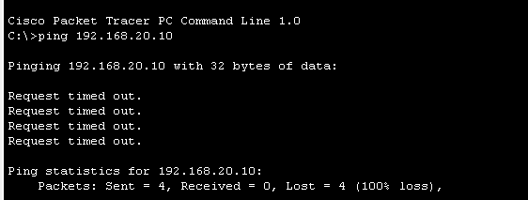
It fails
Let's do the router configuration
The Router Configuration:
! ══════════ R15 (top) ══════════
interface FastEthernet3/0
ip address 192.168.20.1 255.255.255.0
no shutdown
interface GigabitEthernet0/0
ip address 20.0.0.1 255.255.255.252
no shutdown
interface GigabitEthernet1/0
ip address 30.0.0.1 255.255.255.252
no shutdown
!
router ospf 1
router-id 15.15.15.15
auto-cost reference-bandwidth 10000
passive-interface FastEthernet3/0
network 192.168.20.0 0.0.0.255 area 0
network 20.0.0.0 0.0.0.3 area 0
network 30.0.0.0 0.0.0.3 area 0
! ══════════ R14 (left) ══════════
interface FastEthernet2/0
ip address 192.168.10.1 255.255.255.0
no shutdown
interface GigabitEthernet1/0
ip address 20.0.0.2 255.255.255.252
no shutdown
interface GigabitEthernet0/0
ip address 10.0.0.1 255.255.255.252
no shutdown
!
router ospf 1
router-id 14.14.14.14
auto-cost reference-bandwidth 10000
passive-interface FastEthernet2/0
network 192.168.10.0 0.0.0.255 area 0
network 20.0.0.0 0.0.0.3 area 0
network 10.0.0.0 0.0.0.3 area 0
! ══════════ R16 (right) ══════════
interface FastEthernet3/0
ip address 192.168.30.1 255.255.255.0
no shutdown
interface GigabitEthernet1/0
ip address 30.0.0.2 255.255.255.252
no shutdown
interface GigabitEthernet0/0
ip address 40.0.0.1 255.255.255.252
no shutdown
!
router ospf 1
router-id 16.16.16.16
auto-cost reference-bandwidth 10000
passive-interface FastEthernet3/0
network 192.168.30.0 0.0.0.255 area 0
network 30.0.0.0 0.0.0.3 area 0
network 40.0.0.0 0.0.0.3 area 0

! ══════════ R13 (bottom) ══════════
interface FastEthernet3/0
ip address 192.168.40.1 255.255.255.0
no shutdown
interface GigabitEthernet0/0
ip address 10.0.0.2 255.255.255.252
no shutdown
interface GigabitEthernet1/0
ip address 40.0.0.2 255.255.255.252
no shutdown
!
router ospf 1
router-id 13.13.13.13
auto-cost reference-bandwidth 10000
passive-interface FastEthernet3/0
network 192.168.40.0 0.0.0.255 area 0
network 10.0.0.0 0.0.0.3 area 0
network 40.0.0.0 0.0.0.3 area 0

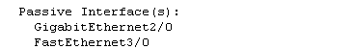
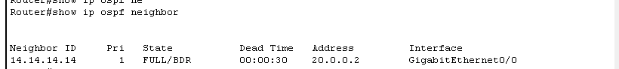
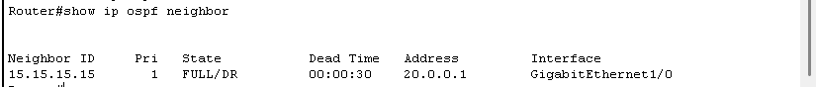
After configuring all above
The neighbours should see each other
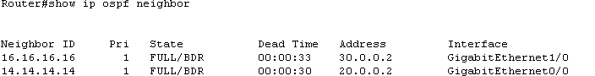

After configuring all the ping should work as follows:
